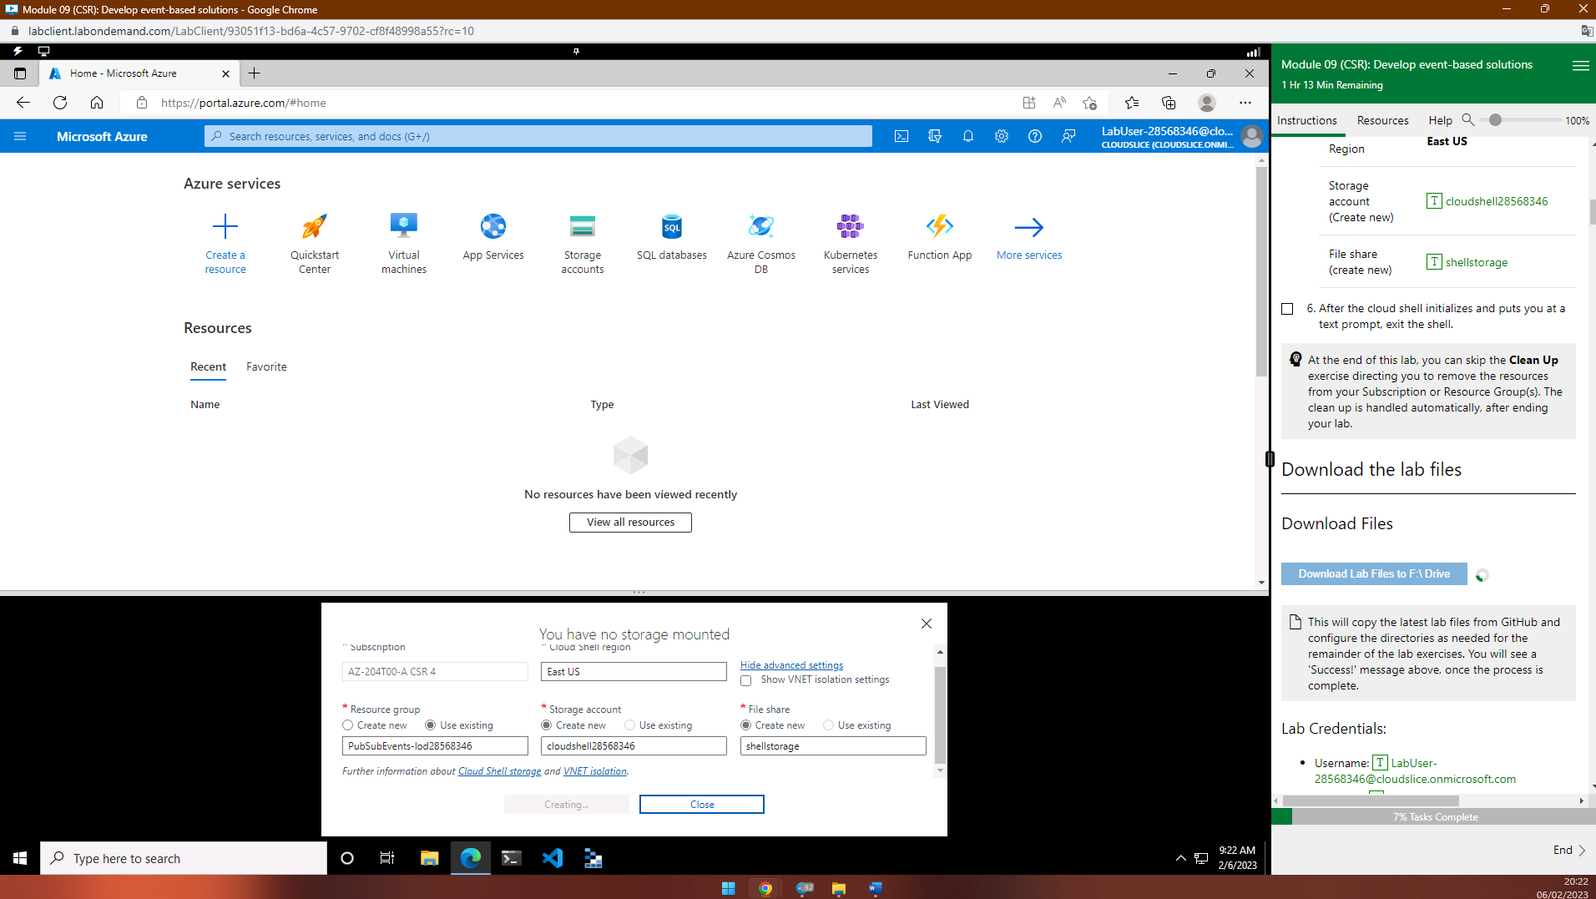

Lab 09: Publish and subscribe to Event Grid events

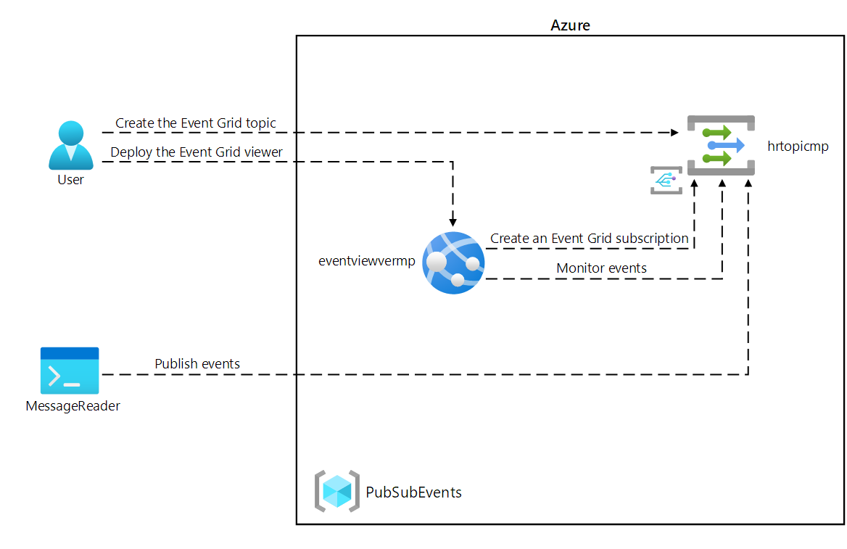

to check if the resource provider "Microsoft.EventGrid" has been registered

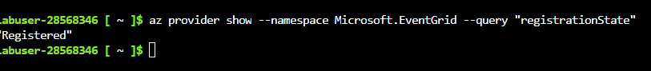

#### **Create a custom Event Grid topic**

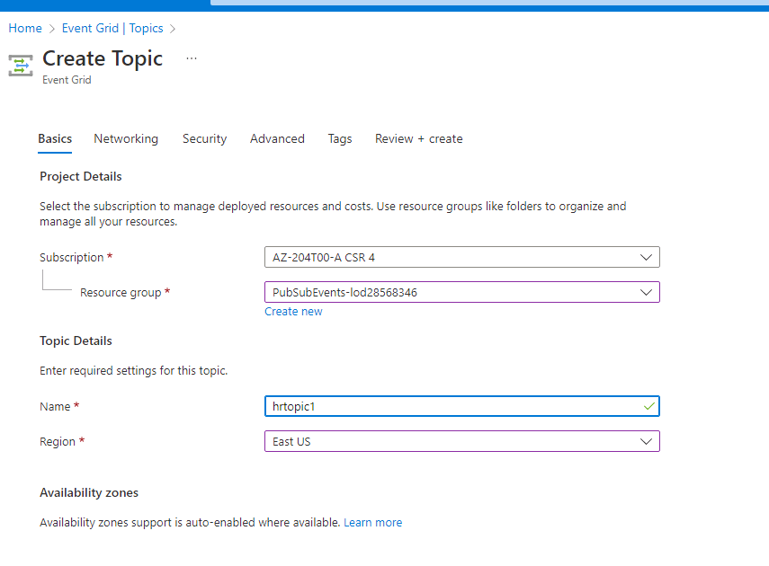

#### **Deploy the Azure Event Grid viewer to a web app**

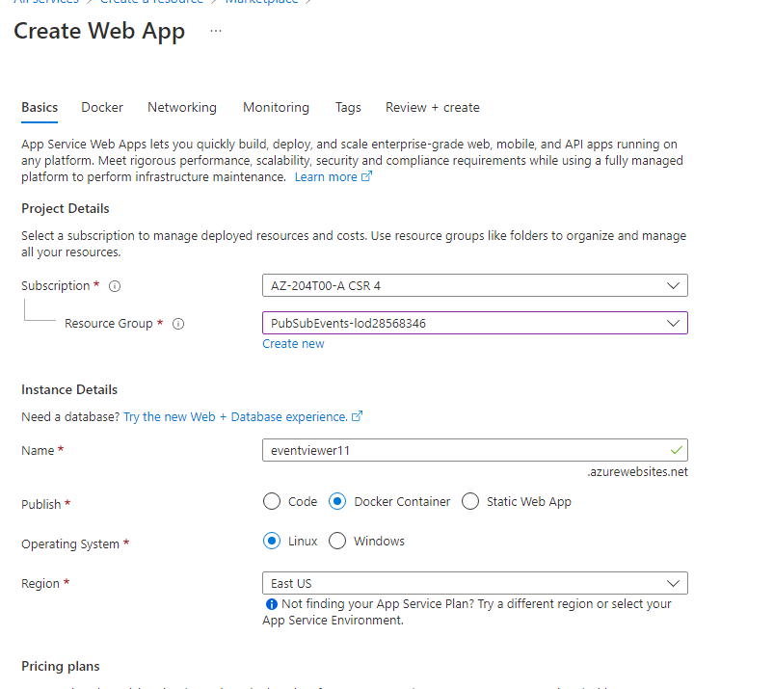

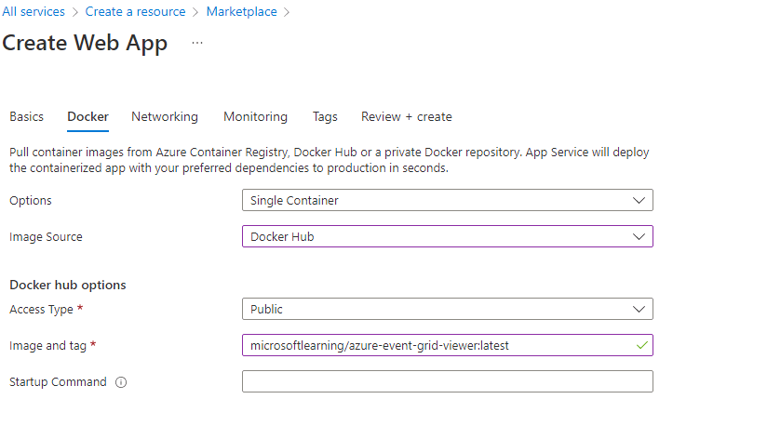

In this exercise, you created the Event Grid topic and a web app that you will use throughout the remainder of the lab.

### **Exercise 2: Create an Event Grid subscription**

#### **Task 1: Access the Event Grid Viewer web application**

Copy link

<http://eventviewer11.azurewebsites.net/>

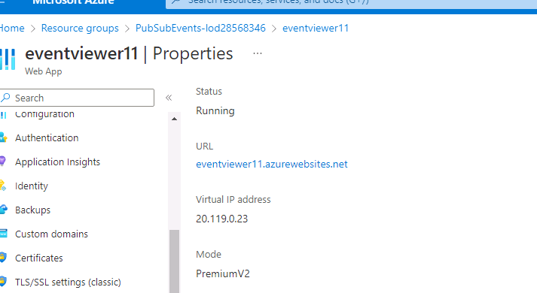

#### **Create a new event subscription (basicsub)**

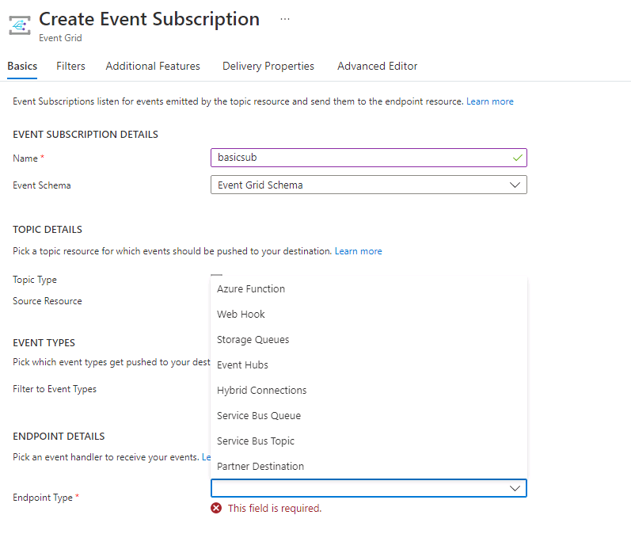

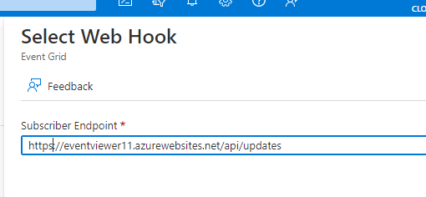

#### **Observe the subscription validation event**

#### 

#### **Record subscription credentials**

https://hrtopic1.eastus-1.eventgrid.azure.net/api/events

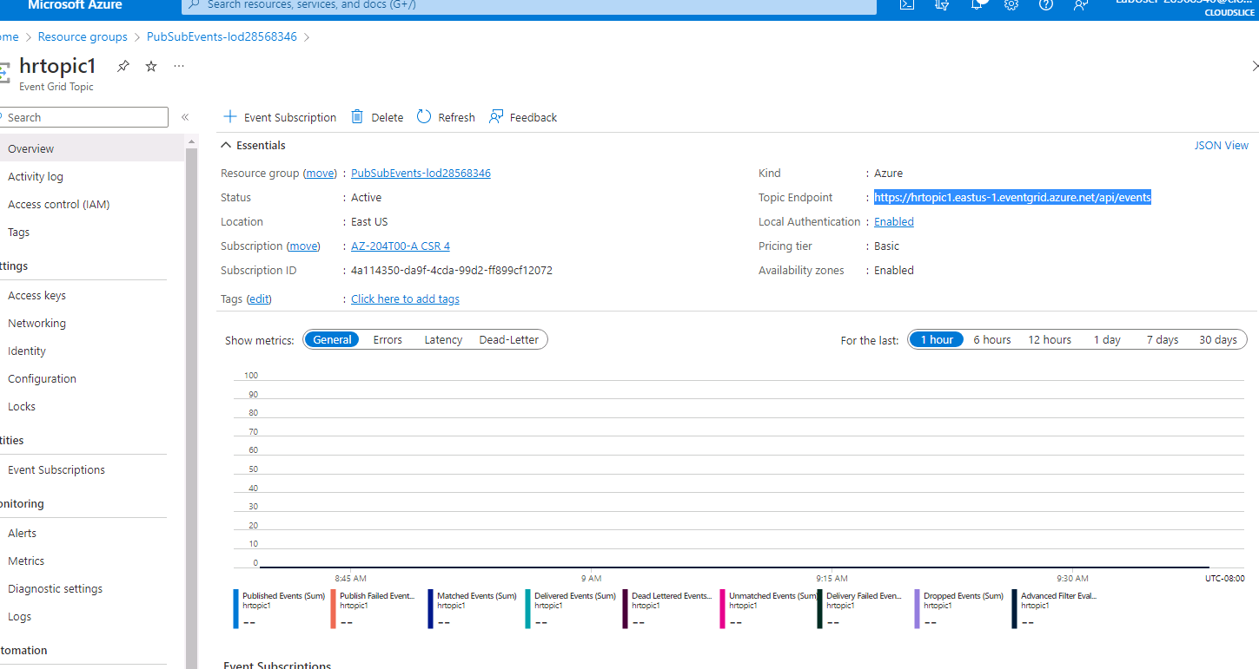

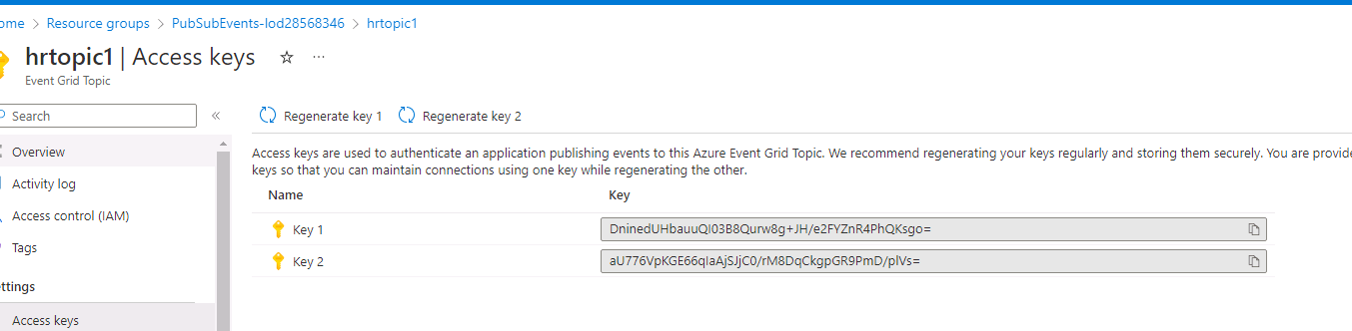

Key1 DninedUHbauuQI03B8Qurw8g+JH/e2FYZnR4PhQKsgo=

### **Exercise 3: Publish Event Grid events from .NET**

 The **dotnet new** command will create a new **console** project in a folder with the same name as the project.

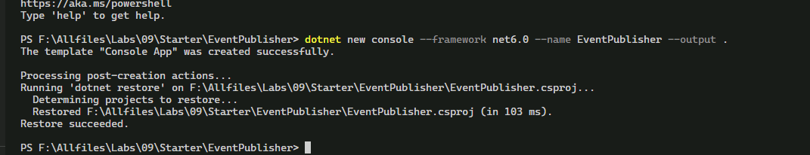

import version 4.11.0 of **Azure.Messaging.EventGrid** from NuGet

dotnet build

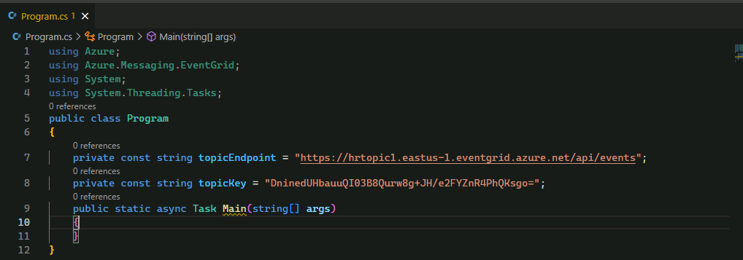

#### **Publish new events**

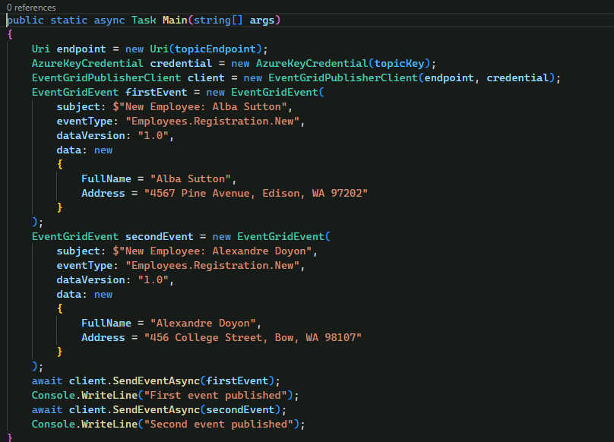

Dotnet run

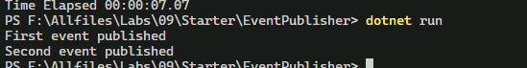

#### **Observe published events**

